Simple Subject

✅ What is Simple Subject
# Source: AI Source: Provided by: [Data Path: Persons Table -> ID Column: 1, Name_En Column: Motasem Essam] -> From: [Chatgpt (GPT-4-turbo)] on [8/4/2025]
A simple subject is the main word (usually a noun or pronoun) in the subject of a sentence. It tells who or what the sentence is about, without including any modifiers.

🔹 Key Features:
# Source: AI Source: Provided by: [Data Path: Persons Table -> ID Column: 1, Name_En Column: Motasem Essam] -> From: [Chatgpt (GPT-4-turbo)] on [8/4/2025]
- It's only the core noun or pronoun.
- It does not include adjectives, determiners, or other words that describe it.
- It must agree with the verb in number (singular/plural).

🔹 Examples:
# Source: AI Source: Provided by: [Data Path: Persons Table -> ID Column: 1, Name_En Column: Motasem Essam] -> From: [Chatgpt (GPT-4-turbo)] on [8/4/2025]
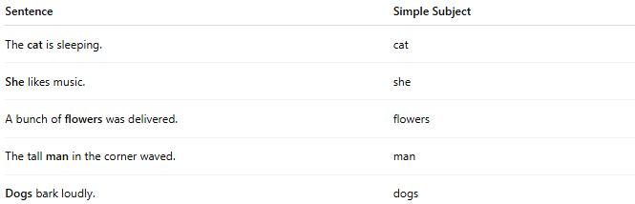
Sentence | Simple Subject
The cat is sleeping. | cat
She likes music. | she
A bunch of flowers was delivered. | flowers
The tall man in the corner waved. | man
Dogs bark loudly. | dogs
In each case, the bolded word is the simple subject — the word that performs the action or is being described.

